Docker file to deploy python application.

# Use the official Ubuntu image as a base

FROM ubuntu:20.04

# Set the environment variable to avoid interactive prompts during package installation

ENV DEBIAN_FRONTEND=noninteractive

# Update the package list and install Python

RUN apt-get update && \

apt-get install -y python3.9 python3-pip && \

apt-get clean && \

rm -rf /var/lib/apt/lists/*

WORKDIR /app

COPY . /app

RUN pip install -r requirements.txt

# Set the default command to run Python

ENTRYPOINT ["python3"]

CMD ["app.py"]

Screenshot for Vi editor

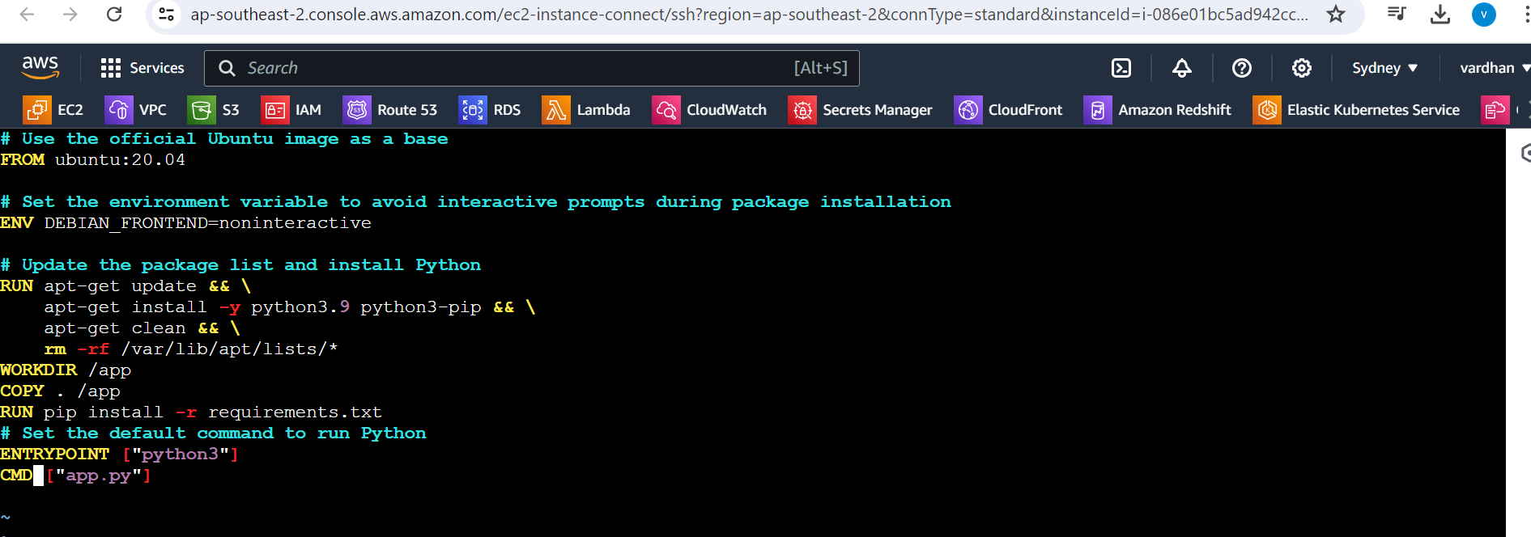

From : pull image ubuntu

RUN : to execute inside container (python and dependencies)

Workdir: to set app directory

COPY . /app to copying files from local to container

RUN : pip install adding dependencies for python code

Entrypoint: it will execute while starting the container inside

CMD: it will execute while starting the container inside (we can override this)

Output:

